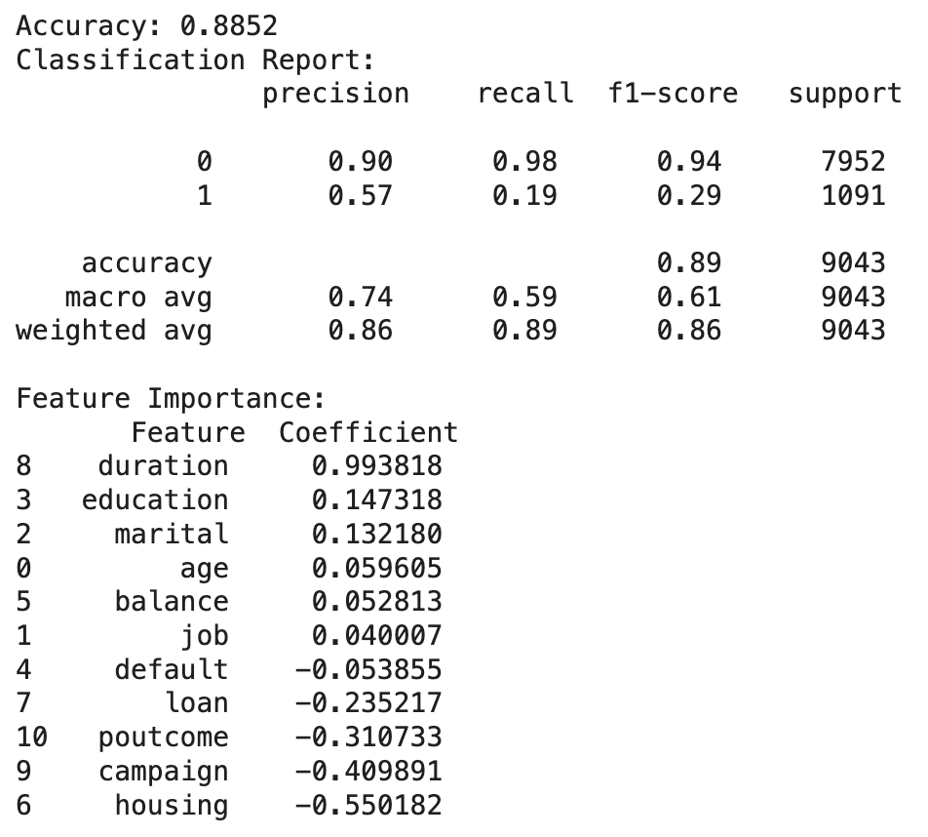

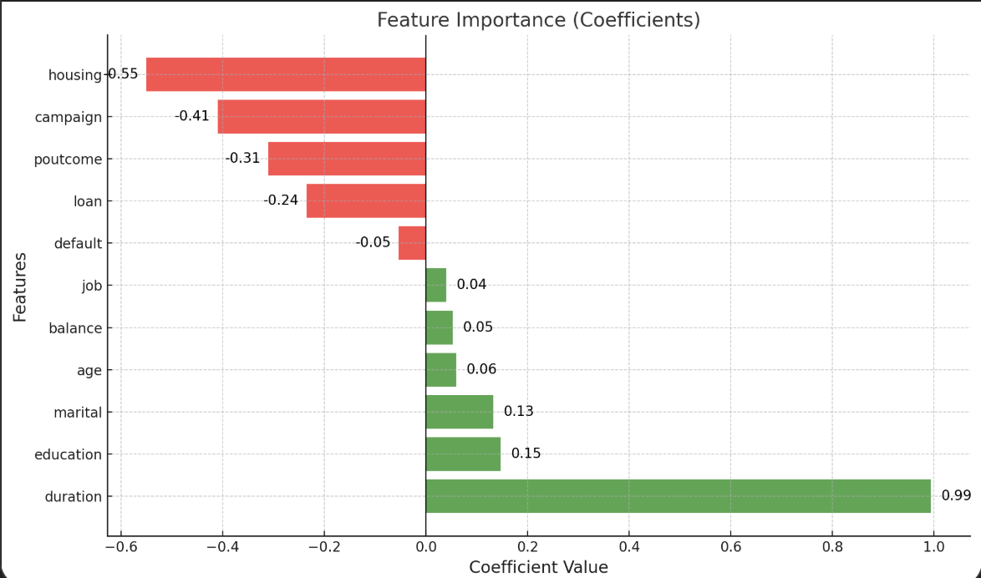

**Key Insights from the Chart:**

1. **Most Influential Features:**
   * **Positive Impact:**
     + **Duration (0.99):** The most critical factor in predicting the outcome, with a strong positive influence.
     + **Education (0.15):** Moderately contributes to a positive outcome, indicating that higher education levels may be associated with the target behavior.
     + **Marital Status (0.13):** Slightly positive, showing some correlation with the desired outcome.
   * **Negative Impact:**
     + **Housing (-0.55):** The strongest negative influence, suggesting housing-related attributes deter the desired outcome.
     + **Campaign (-0.41):** Negative coefficient indicates that this factor could hinder the outcome.
     + **Poutcome (-0.31):** Also negatively correlated, reflecting less favorable conditions for success.
2. **Neutral to Low Impact Features:**
   * **Balance (0.05), Age (0.06), Job (0.04):** These features have minimal positive effects.
   * **Default (-0.05):** Slight negative impact, but not as significant as housing or campaign.
3. **Actionable Recommendations:**
   * Focus efforts on enhancing **duration** and its associated conditions, as it significantly drives outcomes.
   * Mitigate the negative effects of **housing**, **campaign**, and **poutcome** through targeted interventions or alternate strategies.
   * Consider using less influential features, such as **balance** and **job**, as supplementary factors rather than primary predictors.

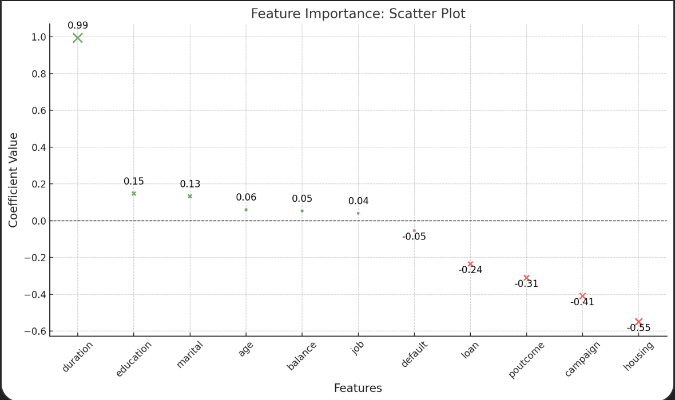

### Scatter Plot: Feature Importance (Coefficients)

#### ****Key Insights from the Chart:****

1. **Positive Impact Features:**
   * **Duration (0.99):** This feature has the largest positive influence, significantly contributing to the target variable.
   * **Education (0.15):** A moderate positive impact, showing that education is correlated with the desired outcome.
   * **Marital Status (0.13):** Slight positive contribution, indicating some influence.
2. **Negative Impact Features:**
   * **Housing (-0.55):** The most influential negative factor, significantly decreasing the likelihood of the target outcome.
   * **Campaign (-0.41) and Poutcome (-0.31):** Both contribute negatively, but less so than housing.
   * **Loan (-0.24):** Negatively correlated, though the effect is less pronounced.
3. **Minimal Impact Features:**
   * Features like **age (0.06), balance (0.05), and job (0.04)** have minimal influence on the outcome.

#### ****Actionable Recommendations:****

1. **Focus on Duration:** Since it is the most impactful factor, prioritize improving or leveraging aspects related to this feature.
2. **Address Negative Features:** Investigate and mitigate the negative effects of housing, campaigns, and past outcomes (poutcome).
3. **Supportive Role of Education and Marital Status:** Leverage these as secondary factors in decision-making models or strategies.